Use Case Realisation Report - Manage Project
FOR
Volunteer Management System
(VMS)

CLIENT
PROJECT | Volunteer Management System (VMS)
TITLE | Use Case Realisation Report - Manage Project
VERSION | 0.1a
DATE | 13-Aug-2011
 | ORIGINATOR
 | Name / Signature | Team 8S
 | APPROVAL
 | Name / Signature | Phung Kim Cuong, Dio
Institute of Systems Science |  | Document Reference
25 Heng Mui Keng Terrence  Singapore 119615 |  | VMS/PM-1.3.1/1

 | Acceptance
 | Customer Signature |  | Customer Signature
 | Name & Designation |  | Name & Designation
 | Date & Company Stamp |  | Date & Company Stamp

Revision History

Date | Version | Description | Author
12-Jun-2011 | 0.1a | Creation | Team 8S
 |  | Refer to amendment history

Table of Contents

1. Brief Description 3
2. Flow of Events 3
2.1 Standard Flow 3
2.1.1 Log-In 3
2.1.2 Change Password 3
2.1.3 Log-Out 4
2.1.4 Request for New Password 4
2.2 Exceptions 4
3. Interaction Diagrams 4
3.1 Domain Collaboration Diagram: Security Management 4
4. Class Diagram 7
5. Derived Requirements 7

Use-Case Realization Report
Security Management

Brief Description
The use case describes the security management of VMS system. Registered user can login/logout the system. Meanwhile, User is able to make changes to password after login. And registered User also can request for a new password when he/she forgets the old password.

Flow of Events
The standard flow of events for this use case and any exceptions are described in the following subsections. See section 3.1 for an overview of the participating Actors and Domain Objects.

Standard Flow
This use case provides the user interface related functionality that will be provided to the User, as follows:

Log-In
To commence using the system functions, the User is required to log-in as follows:
- When the User clicks ‘Login’ link on the NavMenu, the NavMenu.login() is triggered and it will trigger MainController.redirectURL() method to redirect the system to SecurityScreen.
- MainController.redirectURL() will use SecurityScreen .show() to display an authentication form to enable user to input registered username and password.
- User enters the email address and password on the screen
- When user click ‘submit’ button, the SecurityScreen .onSubmit() method is triggered and it will use SecurityScreen .validFormat() method to perform format checking.
- After format checking, SecurityController.validUserPassword() is triggered to do username and password authentication
- SecurityController.validUserPassword() will first use method User.getAllUsers() method to fetch all the Registered User Objects from data persistence and compare the received username with these objects . If the recivedUserName cannot be found, SecurityController.validUserPassword() will use SecurityScreen .displayMsg() operation to instruct the SecurityScreen to display ‘The username has not been registered’
- If username already exists in the database, SecurityController will use User.ValidatePassword() method to compare the received password and the password stored in the object, and return a response to SecurityController informing whether the password is valid or not
- If the password id valid, the SecurityController will use PersonalSecurityScreen.displayMsg() to display ‘Successful login’
- If the password is invalid, , the SecurityController will use PersonalSecurityScreen.displayMsg() operation to instruct the SecurityScreen to display ‘Invalid password’
- Upon a successful login, the system will be redirected to ProjectListingScreen.

Change Password
If the User logs-in successfully, he/she is able to update his/her password as follows:
- When the User clicks ‘Change password’ on the NAVMenu, NAVMenu.ChangePassword() is triggered.
- NAVMenu.ChangePassword() will trigger MainController.redirectURL() to redirect current screen to SecurityScreen.
- After SecurityScreen.show() is triggered, the authentication form will be displayed to enable user to enter old password and new password.
- User will enter the old password and new password. When the user click ‘Change Password’ button, SecurityScreen.OnSubmit() is triggered and it will perform the format validation of new password.
- If the format is not valid, SecurityScreen.displayMsg() will be triggered to display ‘Invalid Format’
- Upon the successful validation, the SecurityController. changePassword() will be triggered and it will call the User.getUserbyUserName() method to get the User Object.
- The SecurityController.changePassword() will use the User.validatePassword()to compare the received password with the one in the object.
- If the password is invalid, the securityController will use SecurityScreen.displayMsg() to display ‘Incorrect Old Password’
- If the old password is valid, the securityController will use the method User.setPassword() to set the new password.
- After setting the new password, the securityController will use the method SecurityScreen.displayMsg() to display ‘Password successfully Changed’
- The use case terminates

Log-Out
- When the User clicks ‘Log Out’ link on the NAVMenu, NAVMenu.logOut() is triggered and it will trigger MainController.logOut() method
- MainController.logOut() will use SecurityController.logout() to clear the user information
- SecurityController.logout() will clear the current session information of the user
- Upon the successful logout, SecurityController.logout() will use HomeScreen.show() to redirect the system to the home screen
- The use case terminates

Request for New Password
- When the User clicks ‘Request for New Password’ link on the NAVMenu, NAVMenu .requestPassword() is triggered and it will use MainController.redirectURL() to redirect current screen to SecurityScreen.
- MainController.redirectURL() will use SecurityScreen.show() to display the SecurityScreen
- The input form will be displayed to enable user to enter the username
- User will enter the username
- The securityController will verify if the user has already registered or not. If not, securityController will use the method SecurityScreen.displayMsg() to display ‘User Name doesn’t exist in the system’
- If yes, the ExchangeServerIF.sendEmail() is triggered and new password will be sent to the user by email.
- The SecurityController. will verify if the user has already registered or not. If not, securityController will use the method SecurityScreen.displayMsg() to display ‘User Name doesn’t exist in the system’
- The use case terminates.

Exceptions
The following exceptions have been identified:
- Invalid Password . If User still failed to enter the correct password after ten attempts. The user account will be locked.
- Invalid New Password. If the new password doesn’t conform to the security format, system will prompt the format tips to assist users
- Invalid email address. If the email address is not registered, system will prompt error message

Interaction Diagrams

Domain Collaboration Diagram: Security Management

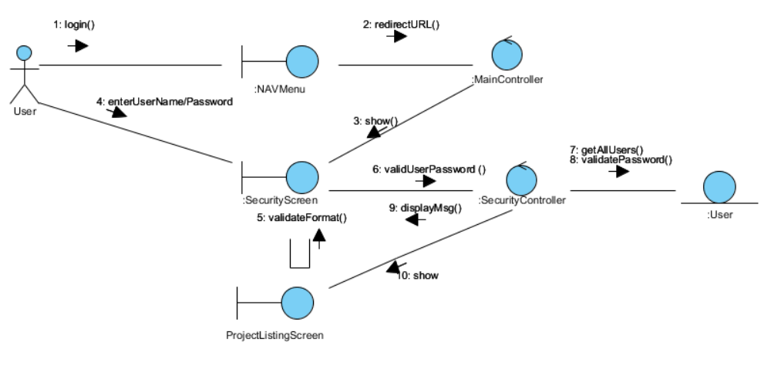

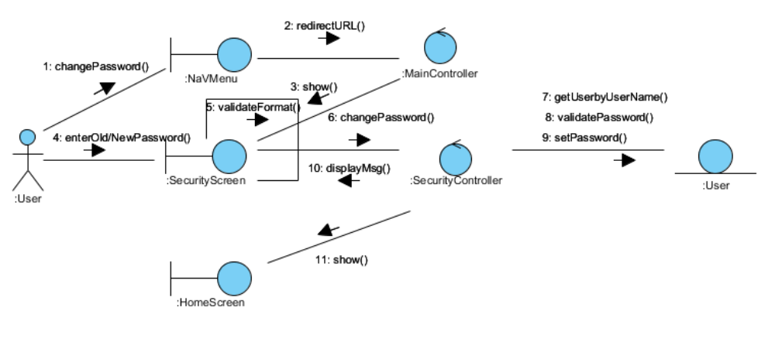
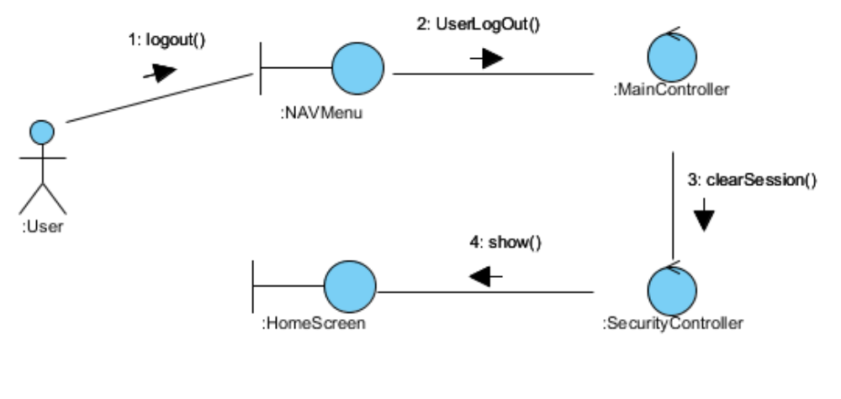

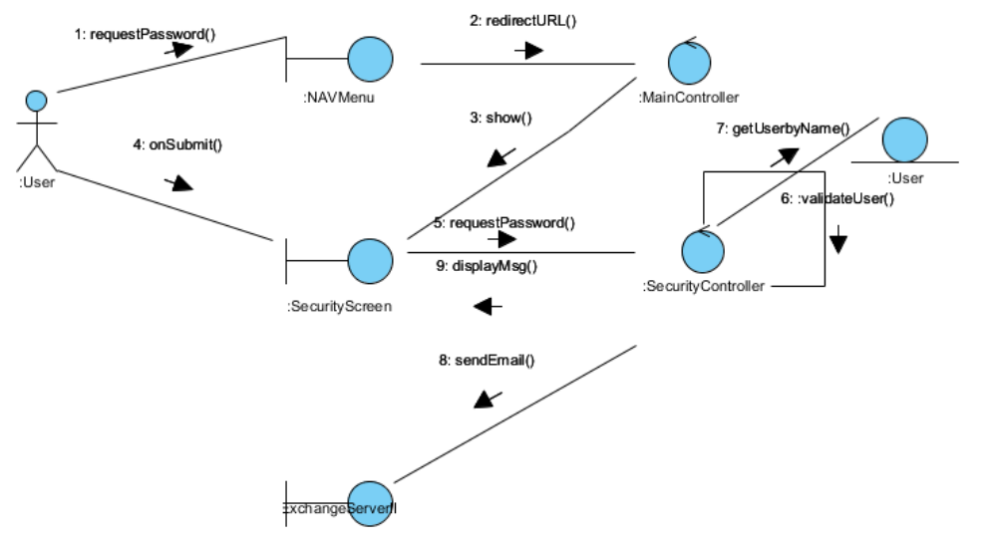

Class Diagram
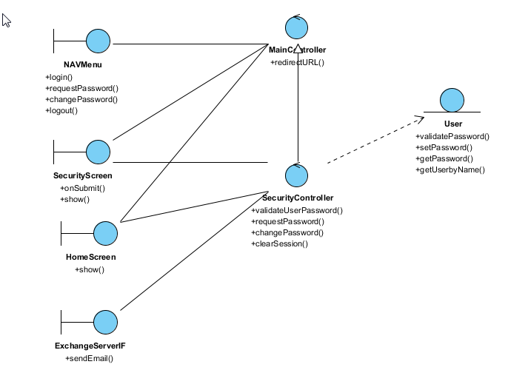

:

Derived Requirements

